Naveen Kumar 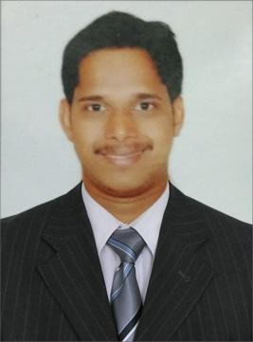

NMAMIT, NITTE

Bachelor of Engineering (BE, 2013-2016)

CGPA - 7.70/10

Email: **Naveenkumarudp@gmail.com**

Phone: **+91-9686810671**

**Career Objective**

I would like to be a part of an organization where I can use and enhance my knowledge and talent for the development of both the organization and myself.

**Professional Exposure**

* Sound knowledge in **Data structures and Algorithm, Design Pattern, Core Java, C++**. Fast learner and ability to learn new technologies. Highly self-motivated, analytical. Ability to work in a fast-paced dynamic environment.
* Good understanding and implementation experience of Software Design Patterns. Good understanding about designing and implementing scalable product.
* Fluency in **Java**(Multithreading, Collection Framework, Exception Handling, Oops concept), C++, Java Script, jQuery, HTML, CSS, JSON, Cocos2d-x, Cocos2d-js, Socket connection, MySQL, SQLite, REST Services, JDBC.
* Knowledge of Google web designer, Flutter mobile UI framework, Adobe Photoshop etc.

**Work Experience**

**Software Engineer***, Juego Studios Private Limited* **Sep 2016 - Present**

* **2048 Game for Hike Messenger**: Developed the entire Game code using Cocos2d-x with the additional functionality of **send and receive** **challenge** as well as a one-step **undo**.
* **Sankal Kite King** Game(Android & iOS) */com.maduracoats.sankalkiteking*
* **Duck on The Run** Game (Android & iOS) to be released.  **/**com.daticient.dotr
* **LetterSchool Educational app /**com.letterschool.lite
* Applied **Design pattern and principle** (singleton, factory design pattern, data manager, touch controller and grid manager) for reduce time complexity.
* Integrated with **API's** such as REST, Facebook, WhatsApp, JSON Parser and other such API's. All of which have modern intuitive UI and UX.
* Implemented efficient data structure for insert and search, delete operation (Reduced time from O(n) to

O (log n)).

**Area of Interest**

**Core Java**, C++, JavaScript, IOT, Data Structure and Algorithm, **Coding**, Solving **Logical** problems, and Hacking.

**Achievements Awards**

* Competitive Programming at **Hacker Rank and Hacker Earth**
* Underwent a semester long course on soft skill entitled “Individual Effectiveness Lab” and week-long workshop titled “Impressive group workshop” for developing the organizational skills, both conducted by I-Pont, Mangalore.

**Declaration**

I do hereby declare that the above statements given by me are true to the best of my knowledge and belief.

Date:

Place: Bangalore Naveen Kumar